Mapping the Nation Activity Instructions:
Using MappingtheNation.net

- Download the Mapping the Nation Activity Worksheet (https://asiasociety.org/files/uploads/26files/Mapping_the_Nation_Activity.docx), review it carefully and select a geographic area (state or county).
- Complete the Getting Started section.
- Open your web browser to MappingtheNation.net

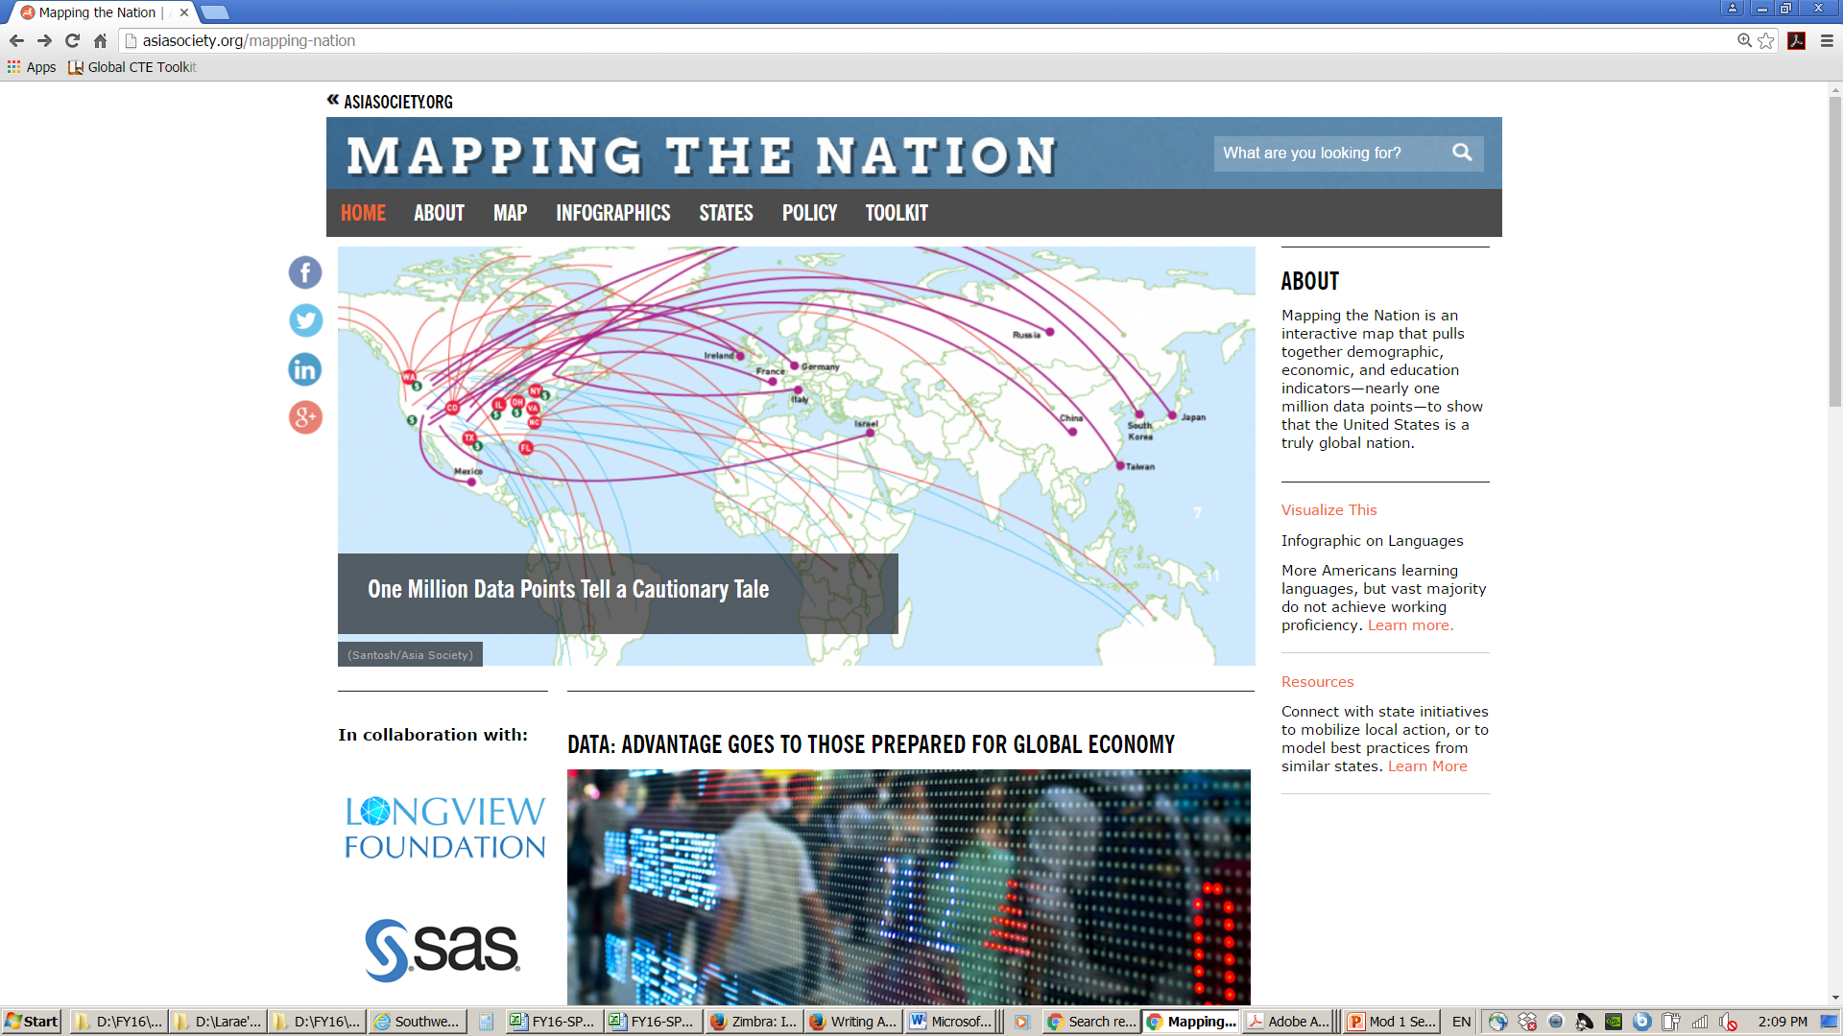

Mapping the Nation is an interactive website that brings demographic, economic, and education indicators together to create a picture of the United States. With nearly one million data points, this picture reveals that the United States is truly a global nation. You can find global connections to your county and/or state using this data. It’s all at your fingertips!

- To get started using the data, click on the word “MAP” in the ribbon just under the title bar. The window that opens looks something like this:

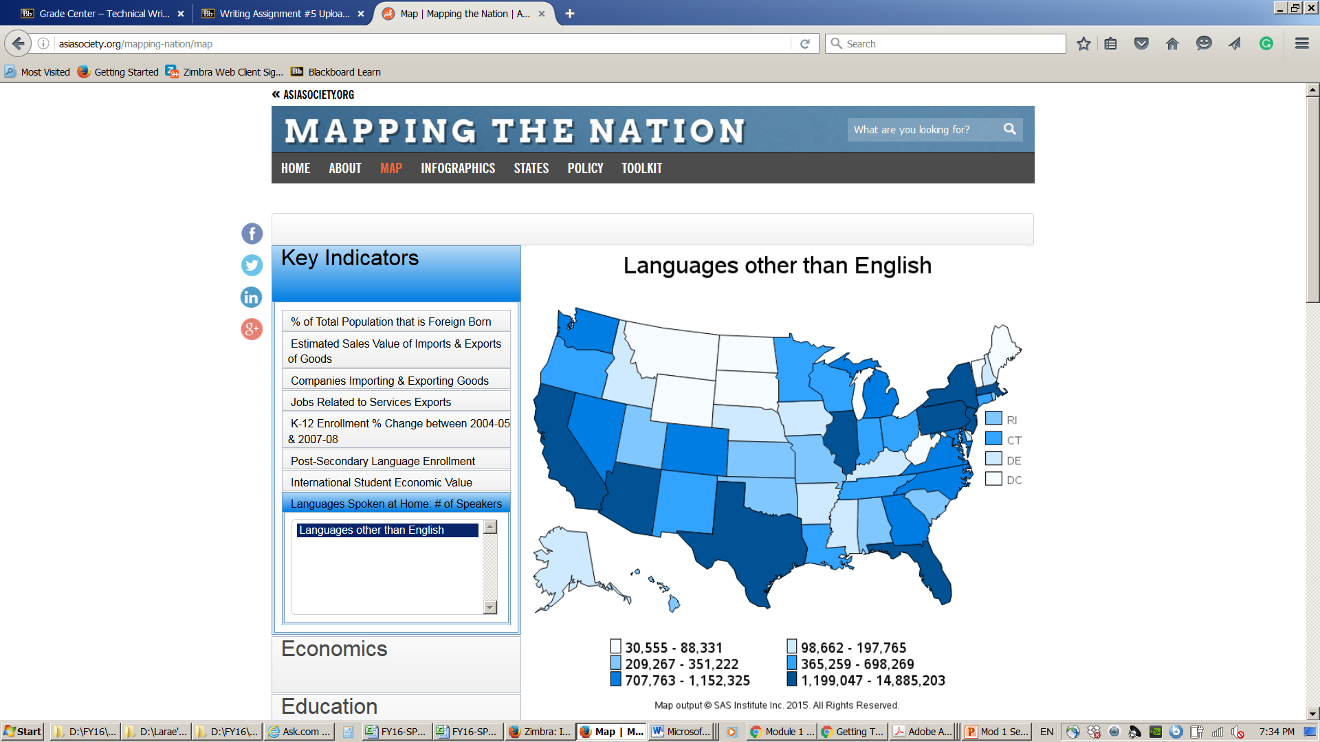

5. Locate the Key Indicators.

This map shows data at the national, state, and county level. The "key indicators" in the upper left corner of the map are some of the most relevant numbers if you are looking for a quick snapshot of what is global in your county. If you are unsure of the county name you are researching, you can find it by typing in the name of a city or a zip code here: http://www.naco.org/Counties/Pages/CitySearch.aspx.

It will also link you to the webpage for any county in the United States.
- Research your selected geographic area using the Key Indicators and other sections of the Mapping the Nation website. Complete the Economics, Demographics, and Education sections of the worksheet.
- Finally, thinking about all of these statistics, complete the Take Action section.

